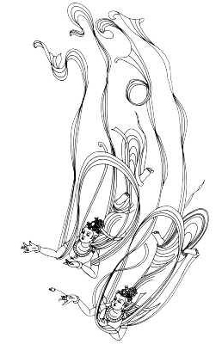
Namo tassa Bhagavato Arahato Sammasambuddhassa
禮敬世尊，阿羅漢，正等正覺者

Homage to Him, the Exalted, the Worthy, the Fully Enlightened One.

METTA SUTTA
慈 經

Karaniyam-atthakusalena yantam santam padam abhisamecca
sakko uju ca suhuju ca suvaco cassa mudu anatimani
欲獲得寂靜的善行者，應如是修學：堪能、誠懇及正直，謙恭、柔和與不慢。
What should be done by one with skill in good, the state of peace to have attained is this:
He should be capable, upright, perfectly upright, obedient, gentle and not proud.

Santussako ca subharo ca appakicco ca sallahukavutti
santindriyo ca nipako ca appagabbho kulesu ananugiddho
知足、易供養，少世俗務，生活儉樸，諸根寂靜，謹慎和謙虛，不攀求於俗家。
Contented, easily looked after, with few duties, simple in livelihood,
serene in senses, prudent and modest, not fawning upon family.

Na ca khuddhamacare kibci yena vibbu pare upavadeyyum
sukhino va khemino hontu sabbasatta bhavantu sukhitatta
不應做任何違戾事，免遭其他智者所譴責。（應如是念言）願一切眾生皆幸福，安穩和快樂。
He should not do even the slightest thing, which other wise-men might deplore. (He must contemplate thus)
May all sentient beings be cheerful and be endowed with happy and secured life.

Ye keci panabhutatthi tasa va thavara va navasesa
digha va ye va mahanta majjhima rassaka anukathula
凡有生命者，若強、若弱、若長、若大、若中、若短、若粗、若細，盡一切無餘。
Whatever living creatures there be, with no exception, weak or strong,
long, huge or middle-sized, or short, minute or bulky.

Dittha va yeva adittha ye va dure vasanti avidure
bhuta va sambhavesi va sabbasatta bhavantu sukhitatta
或可見或不可見，或遠或近，或已生或未生，願一切眾生都快樂。
Those seen (visible) or those unseen (not visible), those who live far or near,
those who are already born or to be born. May all these beings be happy.
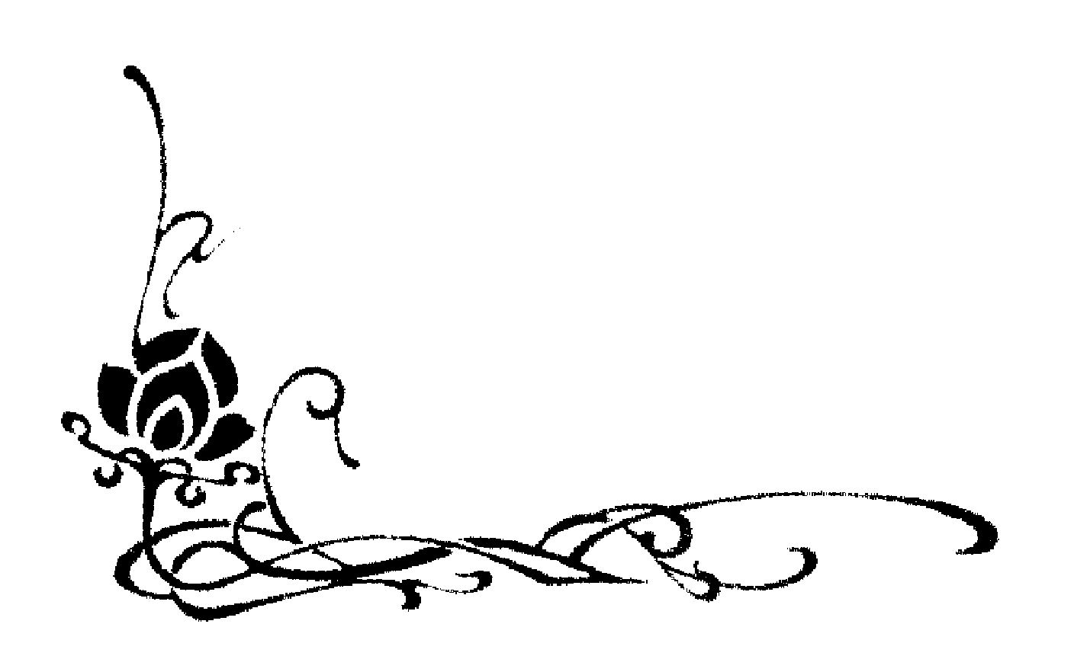
Na paro param nikubbetha natimabbetha katthaci na kabci
byarosana patighasabba nabbamabbassa dukkhamiccheyya
不要欺騙他人，或於一切處蔑視任何人，不應出於忿怒及仇恨而詛咒希望他人痛苦。
May no one deceive another nor despise anyone in any place, through anger and hatred.
May not one desire suffering for each other.

Mata yatha niyam puttam ayusa ekaputtamanurakkhe
evampi sabbabhutesu manasam bhavaye aparimanam

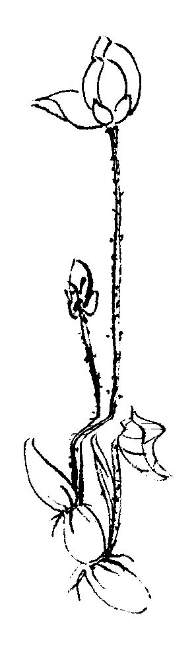
對一切眾生應修習無限的慈愛心，猶如慈母用生命保護自己唯一的兒子。
Just as a mother would protect her baby, the only child with her own life,
even so towards all beings, let one cultivate the boundless spirit of love.

Mettabca sabbalokasmi manasam bhavaye aparimanam
uddham adho ca tiriyabca asambadham averamasapattam
讓無限的慈愛心遍照於十方世界，上、下、左、右，不受阻擾，不懷仇恨，不抱敵意。
Let thoughts of boundless love pervade the whole world,
above, below and across without any obstruction, without any hatred and enmity.

Tittham caram nisinno va sayano yavatassa vigatamiddho
etam satim adhittheyya brahmametam vihara-midha-mahu
無論站著、走著、坐著、躺著，若不昏昧，應確立此念，能如是住者，即云「梵住」。
Whether he stands, walks, sits or lies down, as long as he is awake,
he should develop this mindfulness. This, they say is the Brahma (holy) living.

Ditthibca anupaggamma silava dassanena sampanno
Kamesu vinaya gedham na hi jatuggabbhaseyya punareti
不陷於邪見，具有戒德，具有智見，及斷諸貪欲，當決不再入母胎。
Without resorting to (false) views, being virtuous, endowed with insight,
removing greed for sensual pleasures, he will surely come never again to be born in any womb.

回向功德
祈誦功德殊勝行，無邊勝福皆回向，祈祝家家增福慧，普愿戶戶得安康。

Sharing of Merits
May the result of this good-deed, attain Nibbana, the ultimate cessation of birth, old age, suffering and death, the Absolute Peace. May all beings be happy. May they be without anger and hatred from their hearts and become the embodiment of great love, wisdom and compassion.
Sadhu! Sadhu! Sadhu!

• 我不祈求躲避危險，而是不畏懼的去面對它。
Let me not pray to be sheltered from danger, but to be fearless in facing them.
• 我不祈求緩和我的痛苦，而是以心靈之力戰勝它。
Let me not beg for the stilling of my pain, but for the heart to conquer it.
• 我不在焦慮、恐懼中祈求得救，而是以忍耐心贏取我的自由。
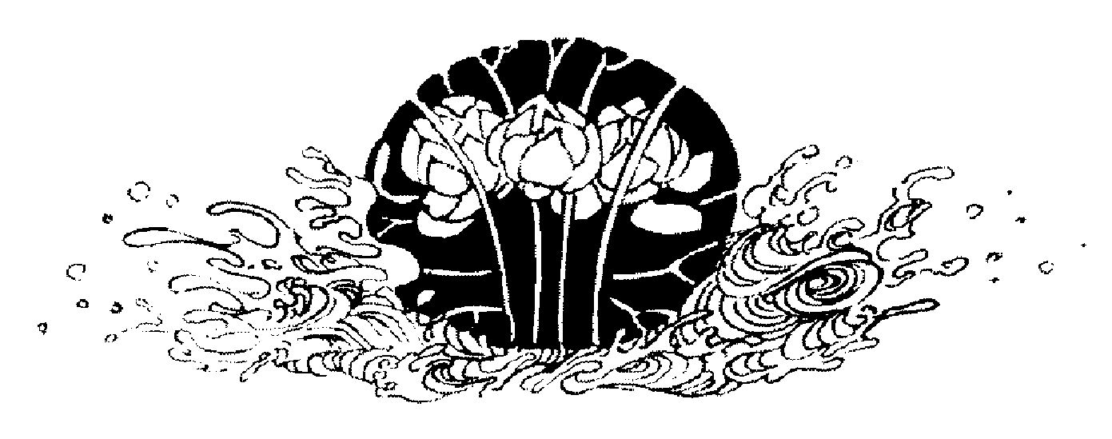
Let me not crave in anxious fear to be saved, but hope for the patience to win my freedom.

